**Graphing and Summary Statistics Instructions**

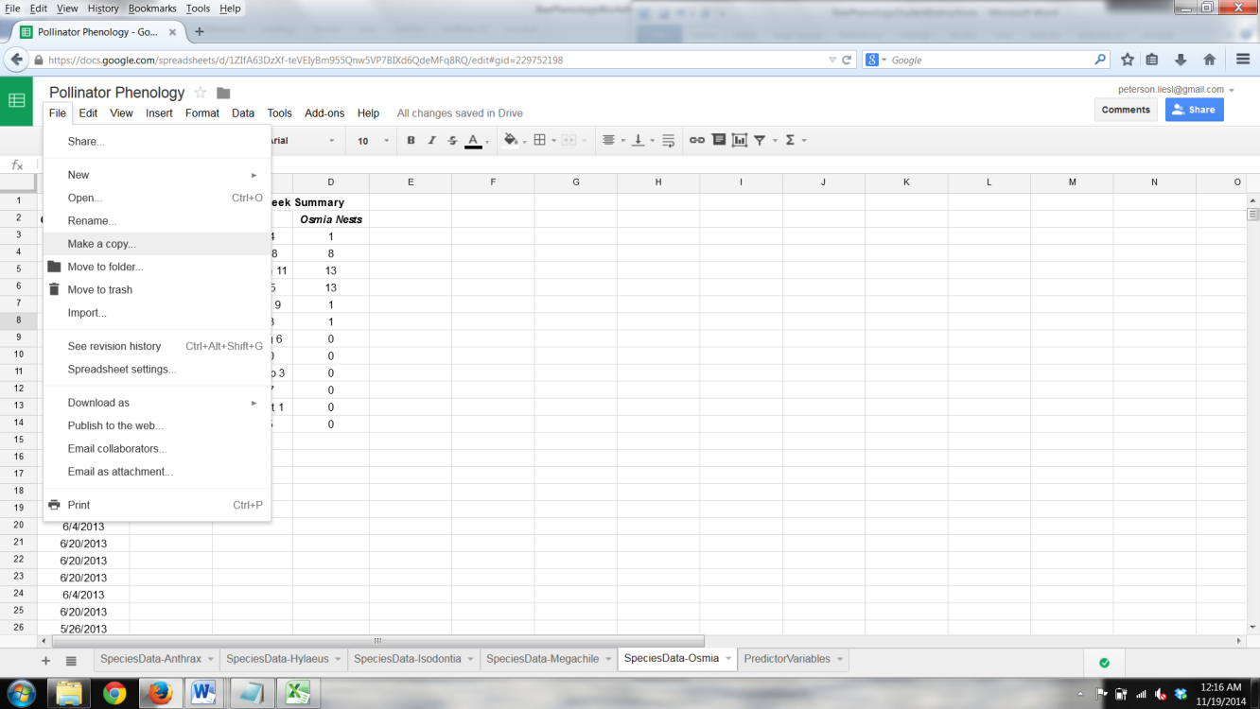**Part 2: Graphing and Summarizing Nest Dates**

1. To graph when pollinators make their nests:
   * Open the Google Spreadsheet titled “Pollinator Phenology.” <https://docs.google.com/spreadsheets/d/1ZIfA63DzXf-teVEIyBm955Qnw5VP7BIXd6QdeMFq8RQ/edit?usp=sharing>
   * IMPORTANT: Click on “File” 🡪 “Make a Copy” and save the file with your group’s name.
   * This spreadsheet has several worksheets:
     + *Species Data (e.g. SpeciesData-Anthrax) –* these worksheets each contain a summary of the nests created by one of five pollinator species in Bees Needs nesting blocks. The data are in two forms:
       - *Daily Data* lists all the nesting dates from Bees Needs nest blocks produced by the species.
       - *Two-Week Summary* summarizes the daily data into the number of nests created by the species in each of the twelve 2-week blocks between May 1 and October 15, 2013.
       - We will need the data in both of these forms to answer today’s question.
     + *Predictor Variables –* this worksheet contains potential explanatory variables for pollinator nesting phenology (timing). We will use it in Part 3.
2. Your teacher will assign you a pollinator species to analyze. Begin with the *SpeciesData* worksheet for the species you were assigned.

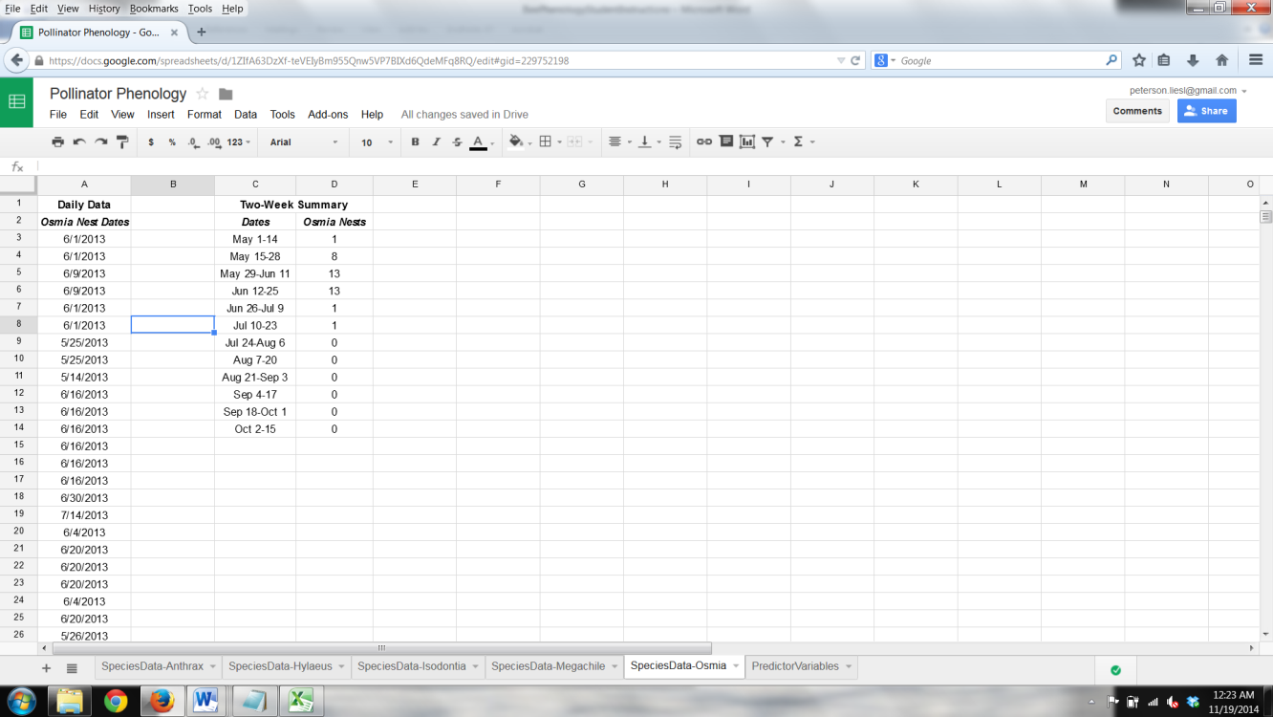

1. 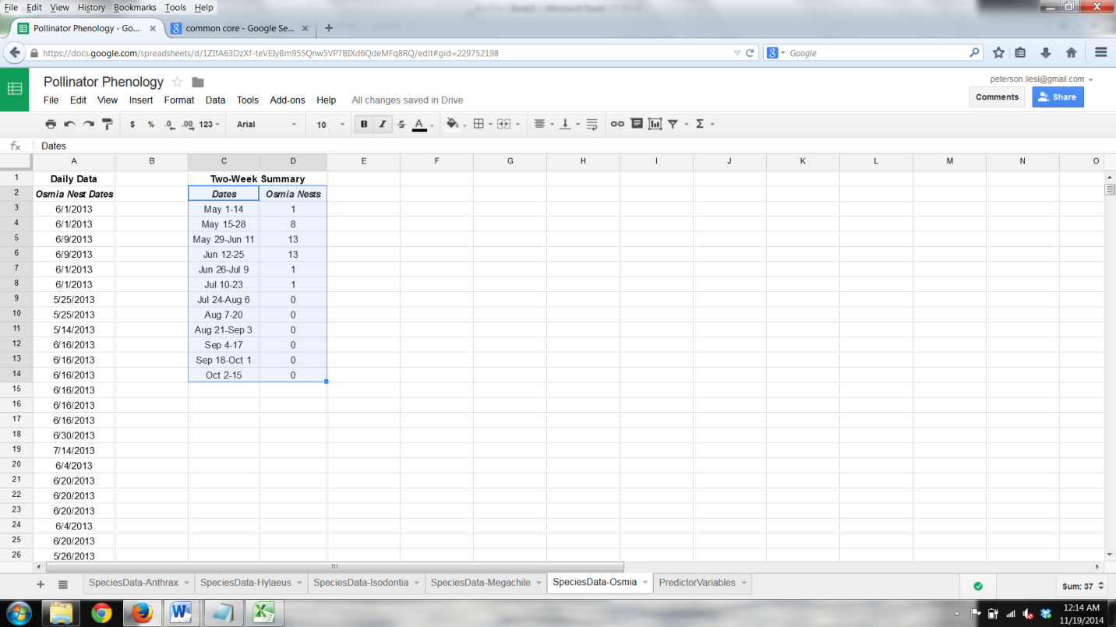Make a graph of nest frequencies for your species:
   * Highlight the two columns you are interested in graphing: your independent variable (the “Dates” column) and your dependent variable (e.g. the “Anthrax Nests” column). Both of these columns are under the “Two-Week Summary” header.

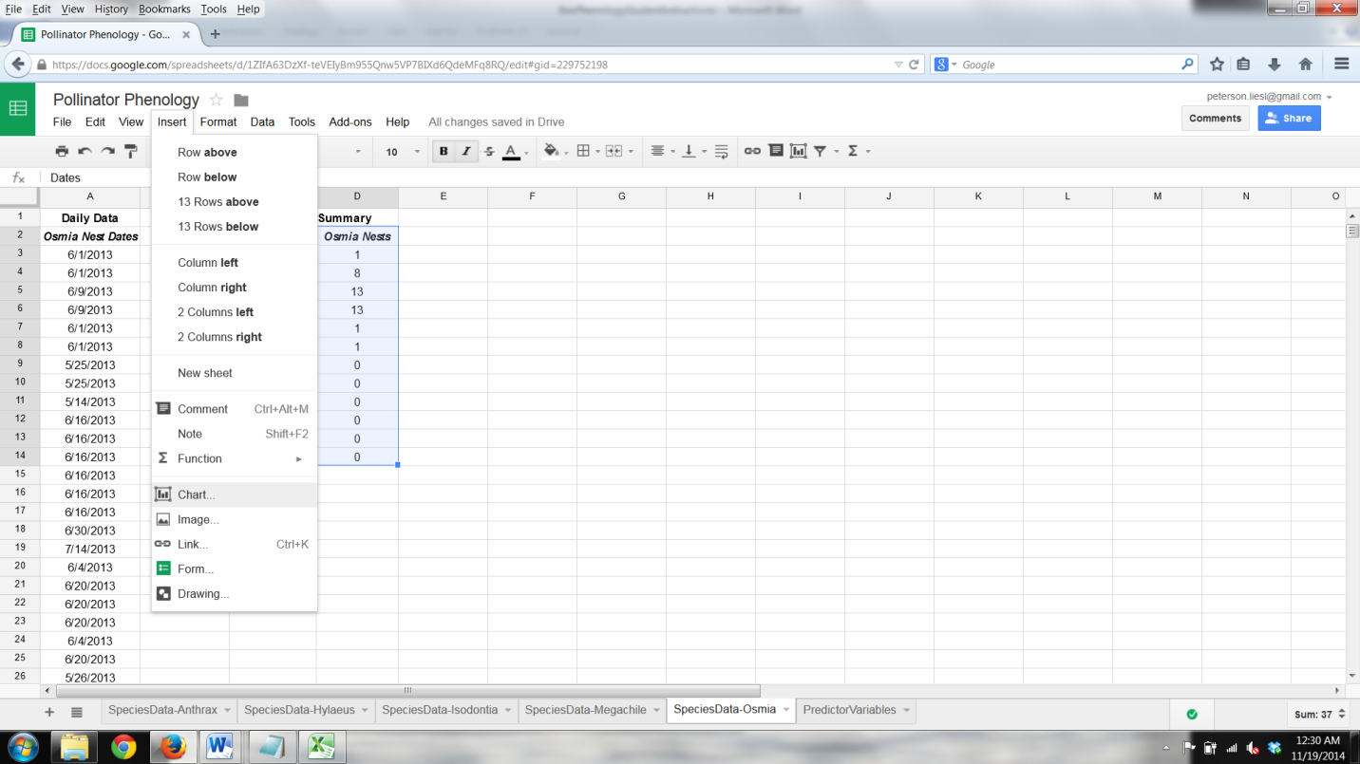

* + With the two columns highlighted, click on “Insert” 🡪 “Chart”
  + When the Chart Editor opens, in the “Start” tab, make sure the box next to “Use row 2 as headers” is checked.

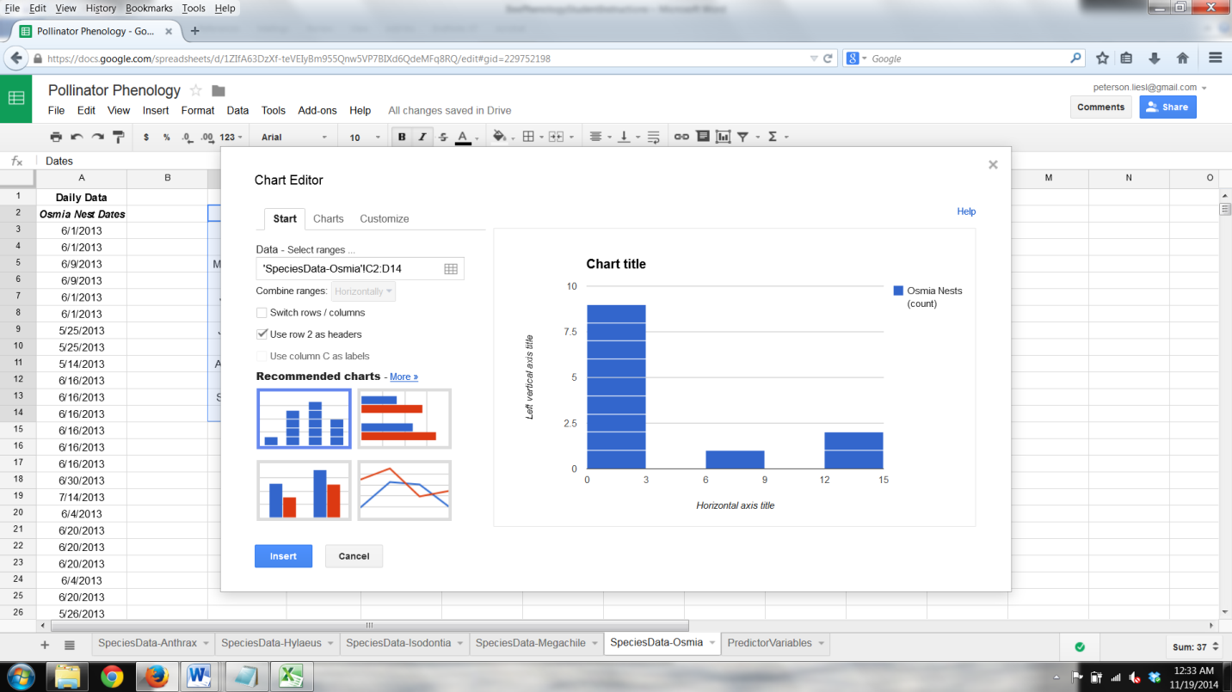

* + 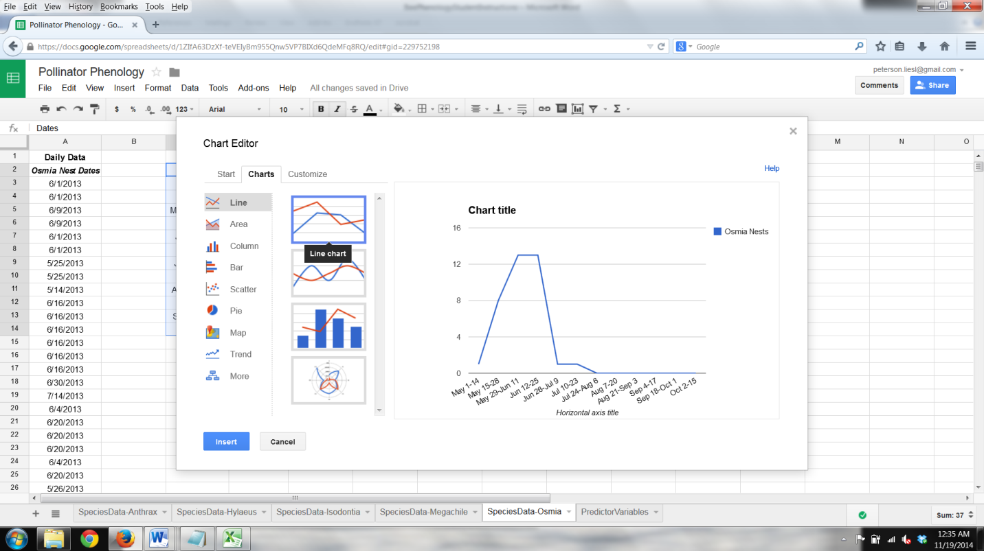Click on the “Charts” tab and select “Line.” Click on the first option that is listed next to “Line” (angled lines, rather than curved lines).
  + Click on the “Customize” tab to provide a chart title, axis labels, and to change other formatting components of your graph, as you so desire.

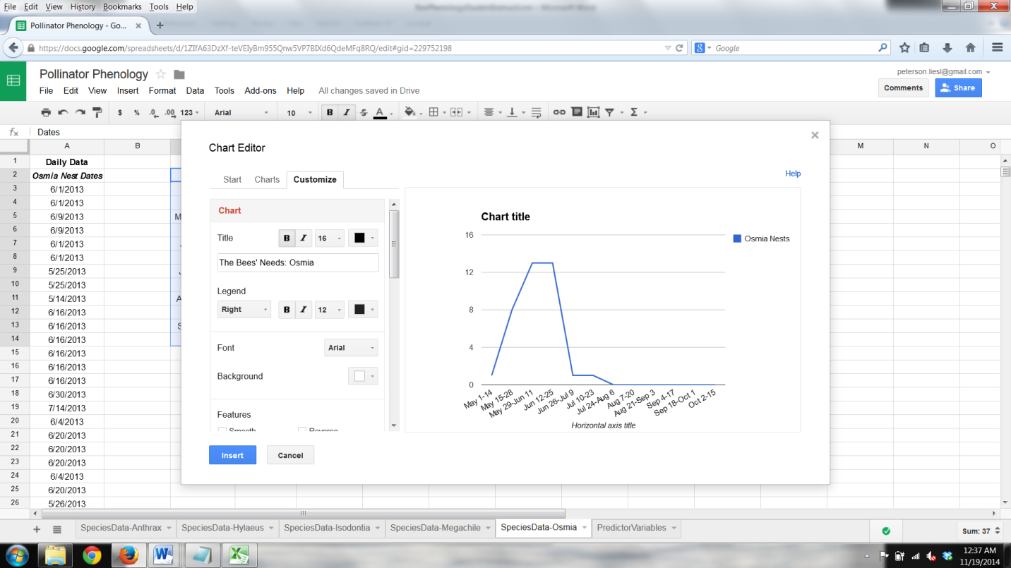

* + When you are done formatting and providing labels, click the blue “Insert” button.
  + **Have your teacher check your graph at this point.**

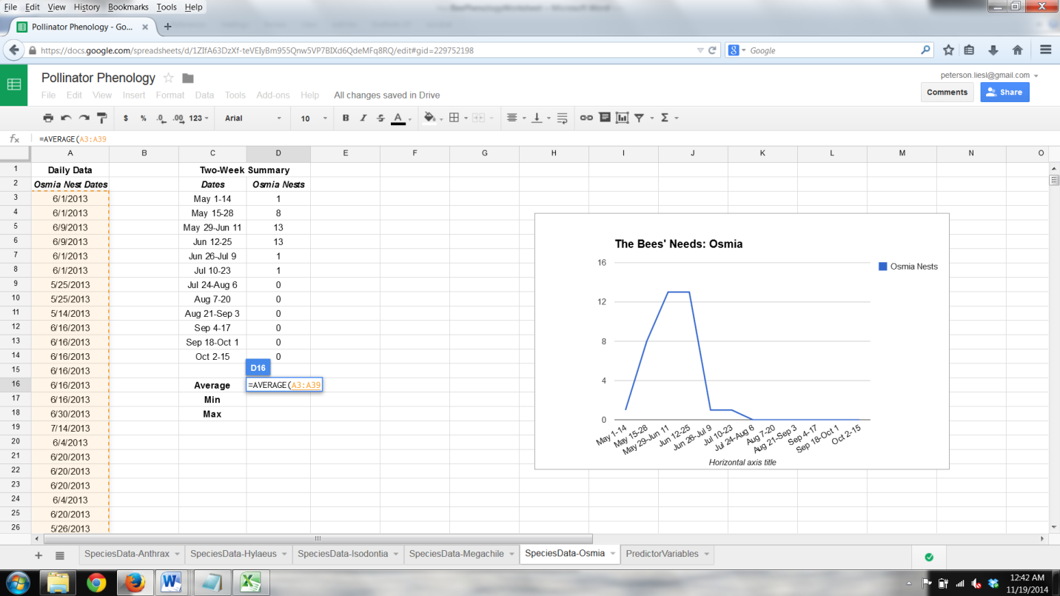

1. ***Analyzing your data.*** What do you see? Now that you have a graph, it is important to figure out what it is showing you. ***Summary statistics*** can also help you better understand your data. You will now calculate the ***average***, ***minimum***, and ***maximum*** nesting dates to help you understand when your pollinator nests.
   * Google Spreadsheets can calculate the ***average*** value of nesting date for you. In the blank cell to the right of the box labeled “**Average**,” type **=AVERAGE()**, click inside the parentheses () and highlight the dates in the “Daily Data” column. Enter your average in TABLE 1 on your worksheet.
   * Next, calculate the ***minimum*** and ***maximum*** of Daily Data using the **=MIN()** and **=MAX()** functions, and enter them in TABLE 1.

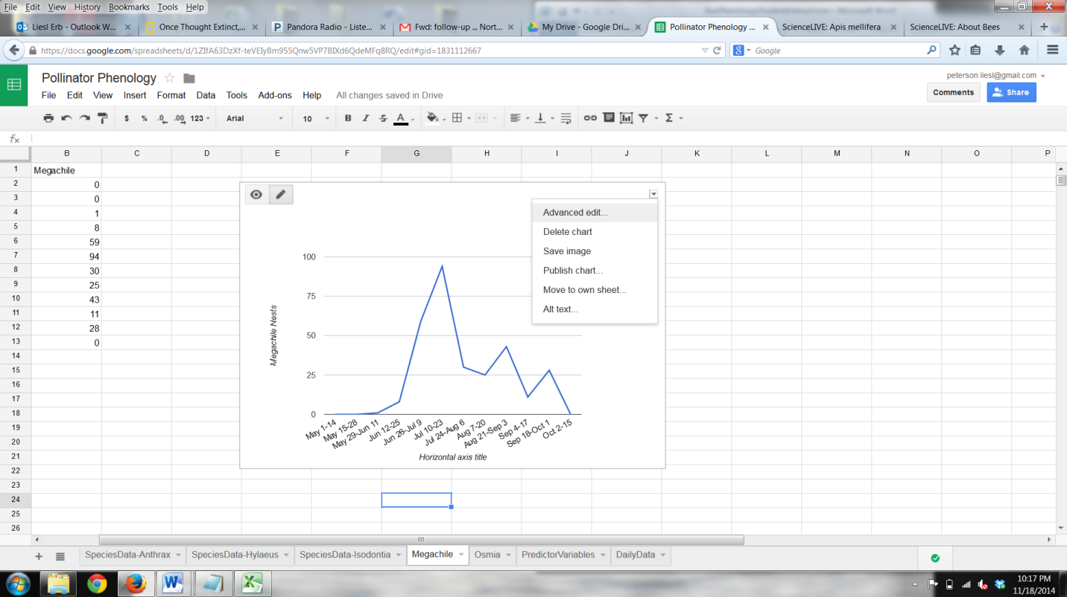**Part 3: What do bees need?**

1. We now want to add more data to the graph you made earlier.

* To do this, click on your graph in Google Spreadsheets.
* Once you have clicked on your graph, a small triangle will appear in the top right corner of your graph.
* Click this and select “Advanced Edit”

1. Once in Chart Editor, click on the “Start” tab and click “Select ranges.”

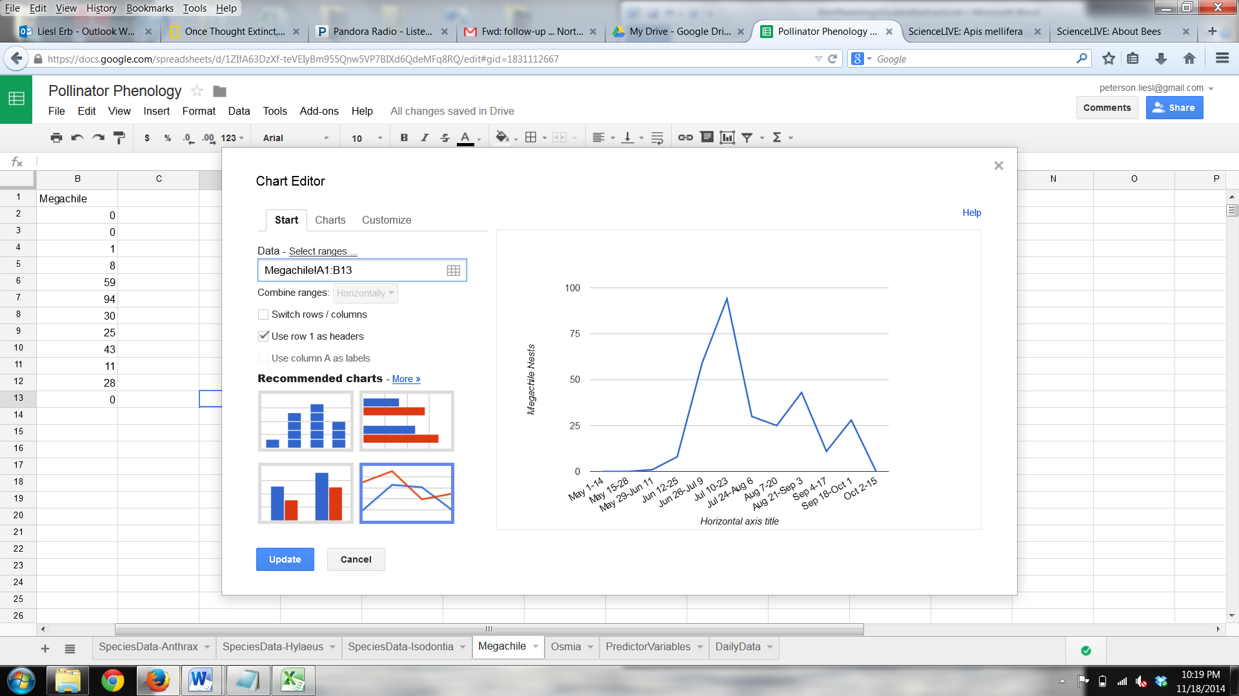

1. In the “What data?” Window, select “Add another range,” click in the new, blank box that appears, and navigate to the column of data you want in the “PredictorVariables” tab of the spreadsheet. Start with the variable that represents your species’ provision resource.

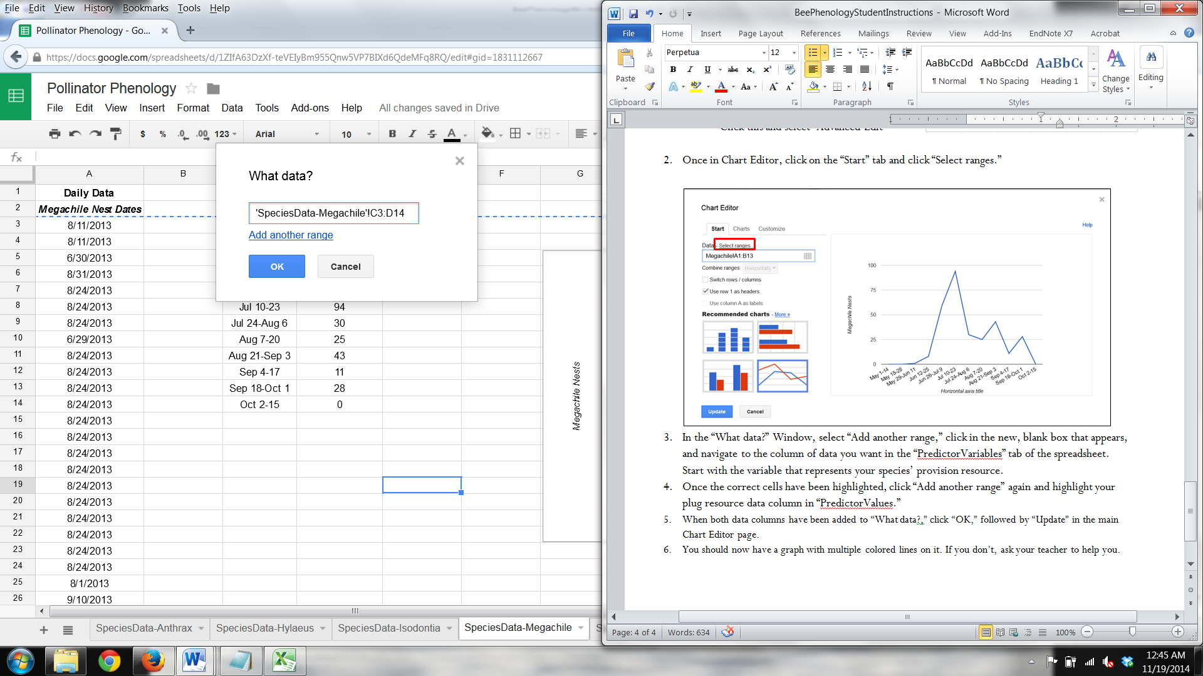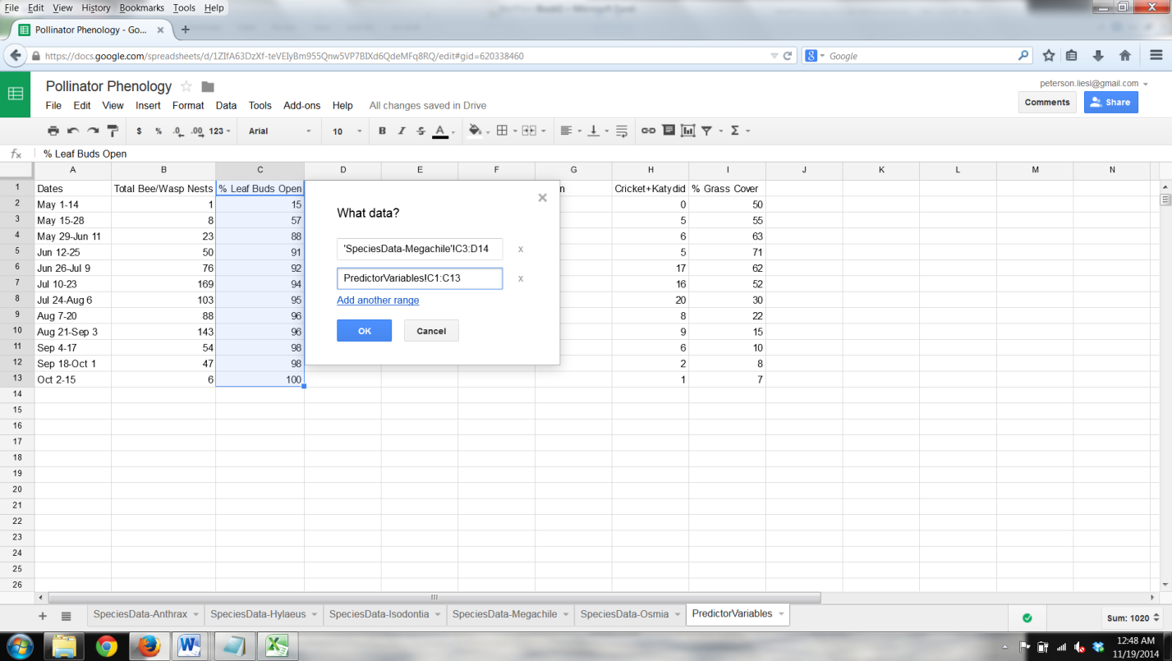

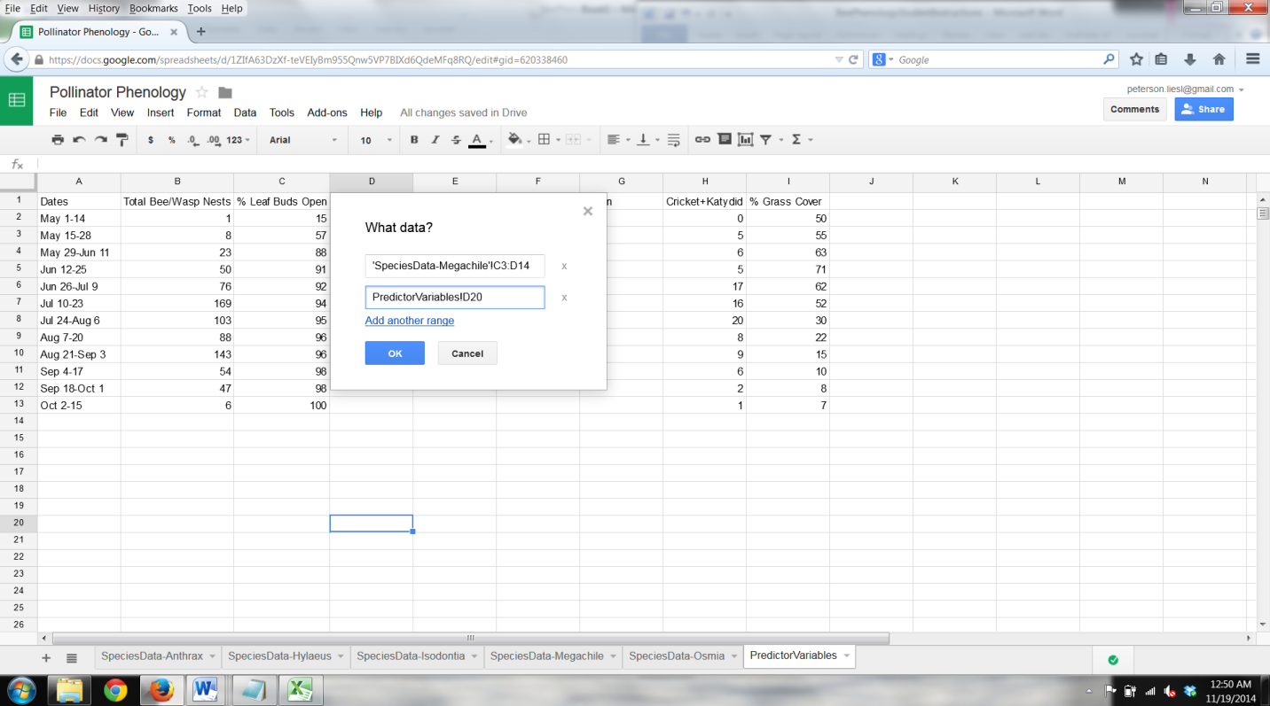

1. Once the correct cells have been highlighted, click “Add another range” again and highlight your plug resource data column in “PredictorValues.”
2. When both data columns have been added to “What data?,” click “OK,” followed by “Update” in the main Chart Editor page.
3. You should now have a graph with multiple colored lines on it. If you don’t, ask your teacher to help you.