Flower Anatomy

Activity: Flower Dissection

Part 1
- You and your partner will be given one flower.
- Draw your flower below. Label the sepals and petals. Refer to the image on the last page as needed.

Figure 1: Labeled Flower

Part 2
- Using your scalpel, very CAREFULLY, make a vertical incision to open your flower.
- Pin the petals and ovary to keep it open.
- Draw your flower pinned open. Label the sepals, anther, stamen, filament, stigma, style, ovary, ovule & pistil. Refer to the image on the last page as needed.
- Use the definitions on the following page to add information to your drawings.

Figure 2 Dissected and Labeled Flower

PARTS OF A FLOWER

Petals – The petals (which are usually bright or bold in color) are the part of the flower that unusally catch our eye. They catch bee’s eye, too! Petals attract pollinating insects such as bees and wasps with their color and scent.

Sepals – Sepals are often green (can be colorful), look like little green leaves under the flower. They cover the outside of a flower bud and function to protect the flower before it opens and elevates the flower for the insects.

Pistil – The pistil is the seed-bearing, “female” (reproductive) part of the flower. It is composed of the stigma, style, and ovary (contaings the ovules). Flowers often contain a single pistil, but may contain several. The ovary contains the developing seeds and is connected to the stigma (pollen-receiving structure) by the style.

stigma – is the tip of the pistil that receives pollen. It is often sticky, or covered with fine hairs or grooves that help the pollen to adhere.
style – is the long stalk-like region of the pistil on which the stigma sits. It connects the ovary to the stigma.
ovary – is the part of the pistil that incloses the unfertilized seeds or ovules and typically develops into a dry or fleshy fruit once pollination takes place.
ovules – are the parts that become the seeds

Stamen – The pollen-bearing or "male" reproductive part of a flower. It is made up of the anther and the filament. A flower may have hundreds of stamens, or only a few.

anther – is the pollen-bearing body of the stamen. Usually a yellow, pouch-like part inside of the flower that holds pollen grains. It is usually on top of a long hair-like stalk. Under a lens, anthers exhibit a wide variety of forms and means of attachment.
filament – is usually narrow and often threadlike stalk on which the
anther sits

Receptacle – Is the generally enlarged top of the footstalk or stem, which supports the other parts of the flower. Some "fruits" are enlarged receptacles rather than ovaries.

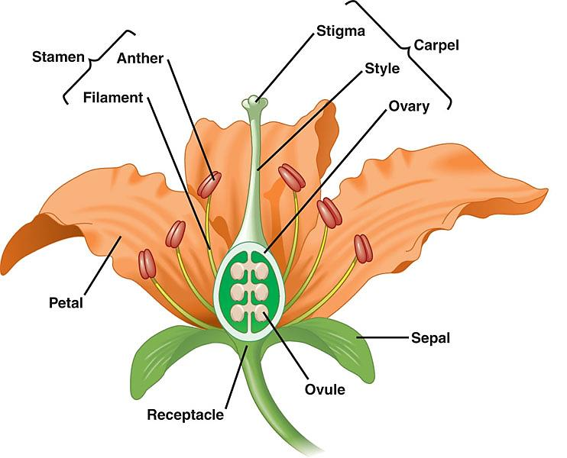
Pistil or Carpel
Stem

