**Part 1: Why Does Body Size Matter?**

1. Pre-lesson quiz: Do you think a small animal or a large animal can stay warmer? Why?
2. Pick a small pika from your Starting Population bag.
3. Measure its diameter and calculate its radius, circumference, and area. Enter these values in the first row of the table below.
4. Repeat for a medium and large pika from your Starting Population bag.

Some handy reminders: d=2r C=πd A=πr2

|  |  |  |  |  |  |
| --- | --- | --- | --- | --- | --- |
| **Pika Size** | **Diameter (in)** | **Radius (in)** | **Circumference (in)** | **Area (in2)** | **C:A** |
| Small |  |  |  |  |  |
| Medium |  |  |  |  |  |
| Large |  |  |  |  |  |

Calculation Space:

1. Does circumference increase as pika size increases? Yes / No
2. Does area increase as pika size increases? Yes / No
3. Do circumference and area increase at the same rates?

The easiest way to tell this is to calculate the ratio of circumference to area (C:A). To do this, divide circumference by area.

* If C:A <1, then area is bigger than circumference.
* If C:A >1, then circumference is bigger than area.
* If C:A = 1, C and A are equal.

For each of your pikas, calculate C:A and enter this in the last column of the table on Page 1. Did circumference or area grow faster as your pikas got bigger? **Circle one: Circumference Area**

1. Given what you know about edge and internal mass and your calculated C:A values, would a small or a large pika lose more heat in the cold? Why?
2. Would a small or a large pika have an easier time cooling off (losing heat) on a hot summer day?

**Part 2: Natural Selection of Body Size**

Are bigger or smaller body sizes being selected for in different environments? We’re going to look at this question at two scales. In both cases we will focus on summer temperatures, which are more extreme in some places than others.

First, we’ll look at pika populations living in different environments that are very isolated from each other: the mountains of Nevada, Oregon, and Washington. You have been assigned a state. Look at your state’s summer temperature and write it on the board. Compare your temperature to the others.

1. Do you think your state will favor small or large body sizes, or will pikas with all body sizes do equally well in your location?
   1. My state will favor:

Large Small Both equally

* 1. Why?

***Simulating Natural Selection: Survival and Reproduction***

1. Flip over your state information sheet and look at the survival probabilities for each size pika in your habitat. Was your prediction in #1 correct?
2. Now let’s see what natural selection looks like over several generations. Open the bag labeled “Starting Population.” Make sure the pikas you measured earlier are included! You should have two large (3”) pikas, 4 medium sized (2”) pikas, and 2 small (1”) pikas. These sizes have been recorded for you in the table below. Given these sizes, what is the average pika body size in your starting population? Enter this value at the bottom of this column in the table.

|  |  |  |  |  |  |  |
| --- | --- | --- | --- | --- | --- | --- |
| **Starting population** | | **Second Year** | | **Third Year** | | **Fourth Year** |
| Size (1,2,3) | Survived? (Y/N) | Size (1,2,3) | Survived? (Y/N) | Size (1,2,3) | Survived? (Y/N) | Size  (1,2,3) |
| 1 |  |  |  |  |  |  |
| 1 |  |  |  |  |  |  |
| 2 |  |  |  |  |  |  |
| 2 |  |  |  |  |  |  |
| 2 |  |  |  |  |  |  |
| 2 |  |  |  |  |  |  |
| 3 |  |  |  |  |  |  |
| 3 |  |  |  |  |  |  |
| --- | --- |  |  |  |  |  |
| --- | --- |  |  |  |  |  |
| --- | --- |  |  |  |  |  |
| --- | --- |  |  |  |  |  |
| --- | --- |  |  |  |  |  |
|  |  |  |  |  |  |  |

1. Given the survival probabilities on your state information sheet, roll a die to determine the pika’s survival. Use the following guide to decide if a pika lives or dies:

* If the pika’s survival is **66%**, then rolling a 1, 2, 3, or 4 will keep it alive. If you roll a 5 or 6, the pika doesn’t survive.
* If the pika’s survival is **50%**, then rolling a 1, 2, or 3 will keep it alive. If you roll a 4, 5, or 6, the pika doesn’t survive.
* If the pika’s survival is **33%**, then rolling a 1 or 2 will keep it alive. If you roll a 3, 4, 5, or 6, the pika doesn’t survive.

1. If a pika survives, keep it in the center of your desk. If it dies, set it aside with your “Extras” bag, to be potentially reborn as a new pika in the next reproductive cycle.
2. Once you have determined the fate of each of your pikas, it is time for the survivors to reproduce! For this exercise, we’re going to keep reproduction simple: each surviving pika should produce another pika of the same size. Enter these pikas AND their surviving parents into the “Size” Column under “Second Year” and calculate the average size of your population.

POP QUIZ: Which of Darwin’s assumptions about natural selection applies to what you just did?

1. As you did with your starting population, now roll your die to determine survival of each second year pika and record this in the table. Allow these pikas to reproduce again, and repeat these steps until you have reached the fourth year.
2. Record your starting population’s average size and your fourth generation’s average size on the

board. Did your population get **bigger**, **smaller**, or stay about the **same size** ? **(circle one)**

1. Explain your answer to #8. Did your population adapt to its environment? How did this compare to groups who measured pikas from other states?

**Part 3: Real Pika Data**

***Latitude and Body Size: State-Based Data***

Now that you have simulated natural selection of body size, let’s see if these patterns hold in the real world! We are going to graph real pika body size data to see if what your class found is really happening to pikas in the western United States. To do this:

1. Open the ScienceLIVE: Pika Body Size Data Google Spreadsheet (<https://docs.google.com/spreadsheets/d/1z6ZjQOEJUpcvPIgw9EE5BHV1Gr5rGZLrwMXit01vfyk/edit?usp=sharing>)
2. IMMEDIATELY resave this document in your own Google Drive account by clicking on **File 🡪Make a Copy** and rename it with your own name. If you don’t have your own Google account, ask your teacher for the ScienceLIVE login.
3. Now we’re ready to make a graph. Because our independent (x-axis) variable is in categories (Washington, Oregon, and Nevada), we should make a bar (or column) graph. To do this, we don’t want to create a giant bar graph of all 120 pikas – that would look confusing (see below)!

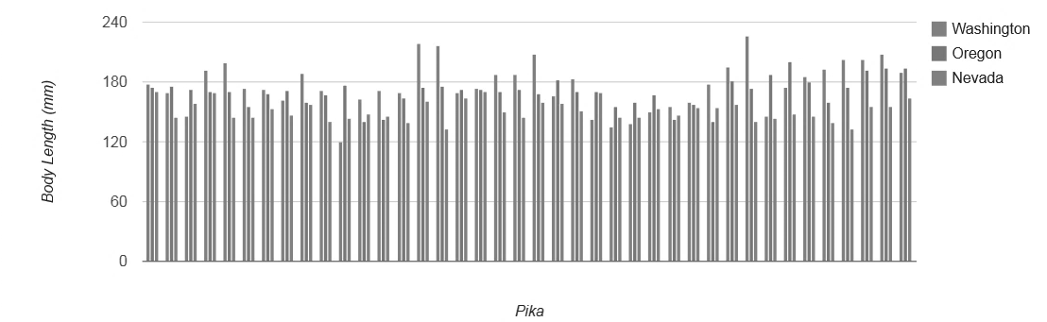

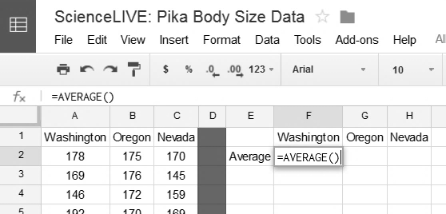So we need to average each state’s pika size first. Fortunately, there is a function in Google Spreadsheets that will do this for us. In the cell below “Washington” and to the right of “Average,” type “=AVERAGE()”.

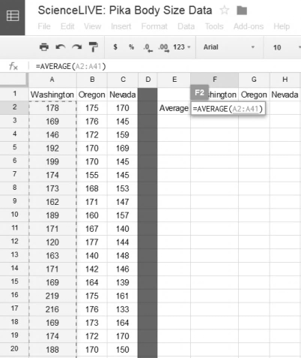

1. Then click inside the parentheses () and highlight the 40 cells with pika body sizes from Washington. The cell for average Washington size should now read, “=AVERAGE(A2:A41)”. Hit “Enter.”
2. Repeat these steps to calculate average pika length in Oregon and Nevada.
3. 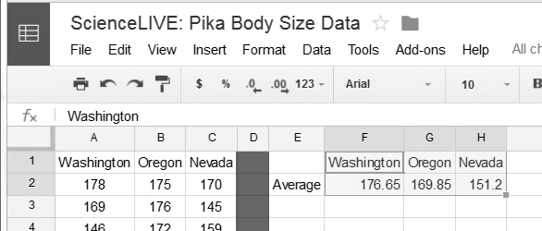Now let’s make a graph. First, highlight the three averages you just calculated AND their state labels, like this:

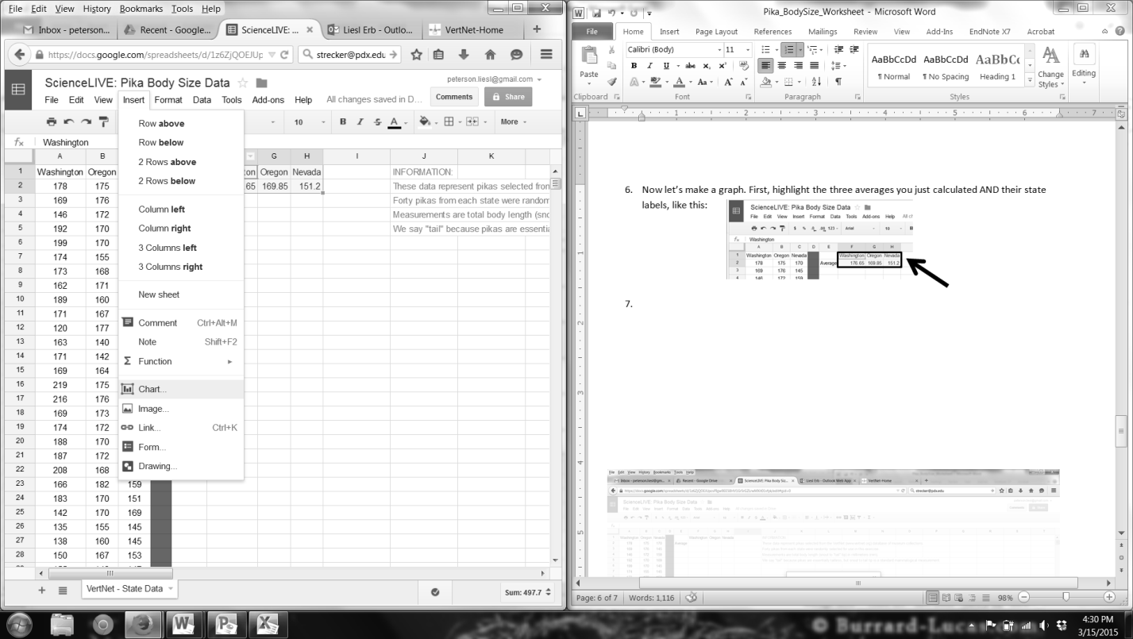

1. With those six cells highlighted, click on **Insert 🡪 Chart**
2. Select **Column Chart**, the bottom left option under “Recommended charts.”
3. Click “Insert.”
4. Click on the axis titles and label them with the appropriate

titles. You can also insert a chart title if you would like.

1. What do you see? Sketch the graph you created in the space below, or call your teacher over to look at your graph on your computer screen.
2. Does the trend the class found hold true in real life?

***Elevation and Body Size: North Cascades National Park***

Our state-based look at pika body size has shown us that different environments can cause pikas to evolve different body sizes. In the case of the Washington-Oregon-Nevada example, temperature is different because of the latitude of the states (how far north each is from the Equator). Scientists have seen similar trends in mountain species, with bigger animals occurring at higher elevations. Do pikas show this trend on mountainsides, too?

Ph.D. Candidate Matthew Waterhouse is studying pikas in North Cascades National Park. Among many questions he is investigating there, Matt wants to know if pikas at low elevations are adapted to the warmer temperatures at the base of the mountains by having smaller bodies than the pikas at the top of the mountain; to do this, Matt collected mass (weight) of the pikas in grams. You will find this data in the Google Spreadsheet. It is the “Waterhouse – Elevation Data” tab.

1. Given what you know about pika body size and temperature, if body size is undergoing selection on an elevational gradient, what trend would you expect to see in body size at high vs. low elevations? Why?
2. Design your own analysis of these data. How will you test if body size is being acted on by natural selection in North Cascades National Park? Describe your methods below.
3. Run your analysis. What did you find? Are there any elevational patterns in body size of pikas in North Cascades National Park?
4. What are some possible explanations for the results you found? Some things to consider:
   1. Think about Darwin’s four requirements for natural selection.
   2. How are the North Cascades measurements different from the state data? Could those differences matter?
   3. How is the study area for the North Cascades data different from the state-based data?
5. If temperatures get warmer in North Cascades National Park, what might you expect to happen to pika body size there? Is there enough variation in the population for selection to occur?