Pika Survival in Summer and Winter Habitats
Written by Heather Batts
Project Dragonfly at Miami University

LESSON SUMMARY:
This lesson plan focuses on how a pika is able to survive in both summer and winter habitats. Students will identify suitable habitat for pikas using prior knowledge of Colorado geography and discover that pikas are only found in alpine regions of Colorado. A pika’s sensitivity to temperature is explored by understanding how behavioral adaptations help a pika survive in both hot and cold environments.
LEARNING GOALS:
- Develop an increased knowledge of a local species.
- Identify where pikas live in Colorado.
- Understand the habitat requirements of pikas in both summer and winter.

MATERIALS:

Large floor map of Colorado OR wall map of Colorado
Pika stuffed toys (3-4) OR paper pika cut-outs printed from the internet (3-4)
1 white tablecloth (large enough to cover several students)
1 white thinner tablecloth with holes (large enough to cover several students)
Fake flowers and plants (enough to spread around the classroom)
3-4 medium sized rocks (larger than the pika toys or pika cut outs)
Optional Evaluation Activity:
Two pieces of blank paper per student
Drawing utensils: Markers, Crayons, Pencils, etc.

STANDARDS

Colorado State Standards Addressed:

Fourth Grade
- Geography 1. Use several types of geographic tools to answer questions about the geography of Colorado
- Life Science 3. There is interaction and interdependence between and among living and non-living components of ecosystems

THE LESSON:
Part 1: Summer Survival
Set up: Desks should be moved accordingly around the map of Colorado either in the middle or at the front of the classroom. Display a photograph of a pika from the internet on the screen in the front of the classroom, or tape a printed picture of a pika to the front wall. Hide fake flowers and plants all around the classroom.
(Optional Evaluation Activity)
Students will draw a pika and what they think this animal needs to survive in the summers and winters living in Colorado’s mountains without any further prompting. Encourage them to label their drawings. Put aside for later. They will repeat the same exercise after the lesson is over. The purpose of this activity is to evaluate the level of understanding prior to and after the lesson.

- Briefly introduce the subject of the lesson, the American pika (See http://www.science-live.org/pika.html for more information). Explain that pikas are animals that live in the mountains of Colorado.

- Lay a large map of Colorado on the floor, OR hang to the wall. Have 3-4 volunteers place a stuffed pika toy OR pika cut out on the map of where a pika might live. Ask the students why they think that pikas live in the mountains and not in the city. What is unique about Colorado’s mountains (cold weather, snow, etc.)?

- Discuss how pikas are very sensitive to temperature extremes. Pikas do well in Colorado’s mountains because it is cooler in the summer time. It is too hot in Denver for pikas to survive. Ask the students how they keep cool in the summer (air conditioning, swimming, etc.). Ask students how they think a pika is able to stay cool in the summer. Even though it is typically cooler in the mountains than the city, it can still get too hot for a pika.

- What can a pika do to stay cool in the summer? Explain that they live among very large rocks and need to retreat underneath them to be shaded. 3-4 volunteers will place the rocks near the pikas on the map. If using a wall map, an alternative is to place pika cut outs on the floor with the rocks.
Part 2: Winter Survival
- Ask students what they think a pika eats (flowers, grass, and plants).
Ask them what happens in the winter in Colorado’s mountains (snow). Ask students how they think a pika can eat flowers and grass if it is covered in snow. Explain that a pika needs the whole summer to gather all the food it needs for the winter. It collects food and stores it under the same rocks it uses in the summer to stay cool. You may try to relate this to a student’s life by asking them if they think they can go to the grocery store with their parents and buy everything they will eat for the whole winter in one shopping trip.

Activity:
- Students will act like a pika and collect the food they will need for the winter. They should gather all of the fake flowers and plants and bring them back into a pile on the floor map, or directly on the floor (Appendix A). They now have all of the food that a pika will eat for the winter. Ask them what they think happens to this food when it snows? Reiterate that pikas store their food under these large rocks that protects their food from the snow.

- Split the students into two groups. One group will represent pikas in southern Colorado and one group will represent pikas in western Colorado. You may put 2 pika toys or cut-outs on the map to demonstrate where they are. Explain to them that it is winter now and it has been snowing all winter. Review how pikas need to keep cool in the summer, but that also means they need a way to keep warm in the winter.

- Cover the western Colorado half of the students in the white tablecloth and cover the southern half of the students in the tablecloth with holes (Appendix B). Explain that it snowed more in western Colorado this year (the students covered in the thick tablecloth). Ask them what group of pikas they think is warmer (the students covered in the thick tablecloth)? Explain that when there is enough snow there is insulation for a pika. The snow helps them stay warm all winter long (they can uncover themselves from the tablecloths).

- Ask the students if they think a pika hibernates (you may need to explain the definition of hibernation). Remind them of how they just gathered all the food a pika would need for the winter. Pikas stay active all winter long underneath the snow and rocks and they eat the food they collected. Pikas need these rocks in the summer to stay cool and they need snow to help keep them warm.

OPTIONAL Evaluation Activity (continued):
After completion of the lesson, have the students draw on a new piece of paper what a pika needs in the summer and winter to survive (Appendix C) Make sure their names are on the papers to compare individual students (compare pre/post drawings to evaluate level of understanding).

Appendix A
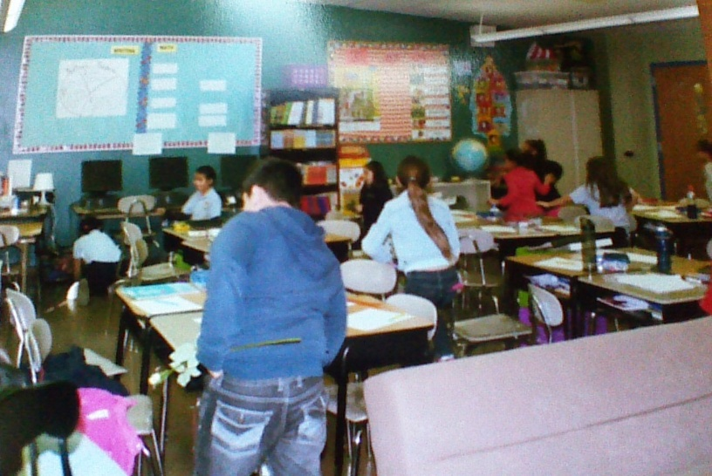
Students act as pikas in the summer by gathering fake flowers and plants around a classroom

Appendix B

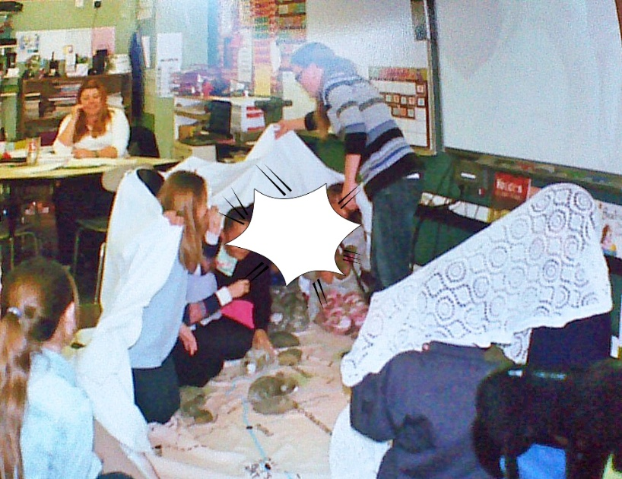
Students being covered up by “snow” to emphasize how pikas need enough snow for insulation throughout the winter

Appendix C
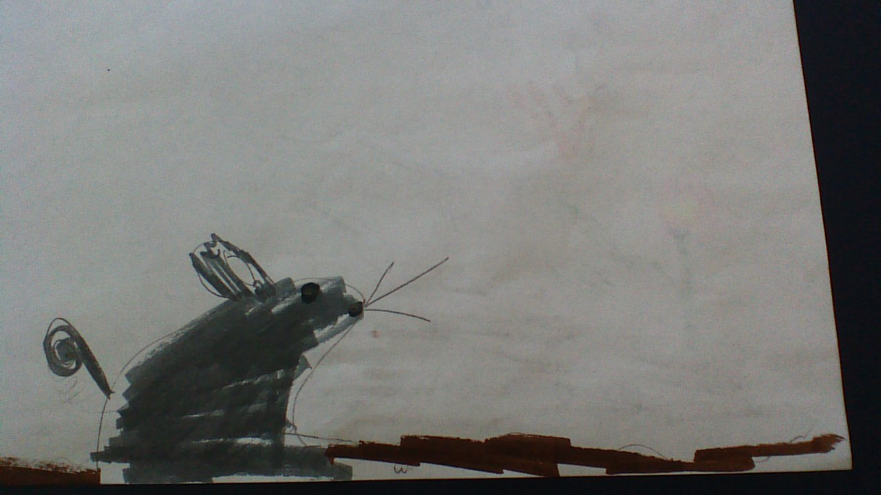
Pre-lesson drawing of a pika by a 3rd grade student
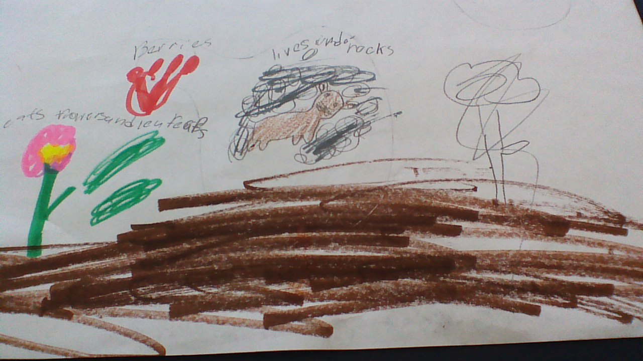
Post lesson drawing by same student

