**LESSON SUMMARY:**

This multi-part lesson focuses on natural selection of body size in pika populations. Part 1 focuses on the importance of body size in animal thermoregulation, using geometry to assess heat loss in different size pikas. Part 2 is an exercise in natural selection, in which students simulate several generations of pikas and how the population’s average body size changes depending on the environment they are in. Part 3 allows students to analyze and graph real pika body size data and interpret their results.

**LEARNING GOALS:**

1. Use geometry to demonstrate why the body size of an animal affects its ability to thermoregulate.
2. Be able to explain the concept of natural selection and the four requirements necessary for natural selection to occur
3. Summarize data using averages and graphs in Google Spreadsheets
4. Develop methods to analyze a new data set and explain the trends found in the data

**PREREQUISITE KNOWLEDGE:**

This lesson is designed to give students practice with geometry, data summary, and graphing. Depending on your class’ background, revisiting graphing basics as well as the mathematical concepts of circle area, circumference, ratios, averages, and probability may be helpful prior to this exercise.

**MATERIALS:**

* Parts 1 and 2 of this exercise can be done in a normal classroom with students working in groups of 2-4. Part 3 of this exercise is computer-based and should be conducted in a computer lab. Students can work on Part 3 in groups or individually.
* Students should receive a worksheet for use on all three parts of the lesson.
* At the beginning of Part 1, each group should receive two bags of circular pikas, one “Starting Population” bag containing 2 large pikas, 4 medium pikas, and 2 small pikas, and a second “Extras” bag containing 8 large pikas, 6 medium pikas, and 8 small pikas. These circle pikas can be found in the “Circle_Pikas.doc” file on the website. The file contains all the pikas needed for one group, so you should make as many copies of the document as you have groups.
* At the beginning of Part 2, each group should be issued a six-sided game die and a

single state information sheet for one of the three focal states (WA, OR, NV). These should be issued map-side up and students should be instructed to NOT flip them over until told to do so on their worksheets. These information documents can be found in the State_Info_Sheets.ppt file.

* Part 3 uses Google Spreadsheets, however a Google account is not necessary to use the data. You can log in using scienceliveoutreach, password: k*12class if you do not have a Google account.
* All materials are available online at [science-live.org/teachers](http://science-live.org/teachers)
* If your school’s internet capabilities aren’t ideal for this kind of lesson, contact us at [erbp@colorado.edu](mailto:erbp@colorado.edu) for an MS Excel version of the exercise.

**STANDARDS:**

**Colorado State Standards Addressed:**

***Sixth Grade***

* *Life Science 1.* Changes in environmental conditions can affect the survival of individual organisms, populations, and entire species.
* *Mathematics 1-1*. Quantities can be expressed and compared using ratios and rates.
* *Mathematics 3*-*1*. Visual displays and summary statistics of one-variable data condense the information in data sets into useable knowledge.

***Seventh Grade***

* *Life Science 1.* Individual organisms with certain traits are more likely than others to survive and have offspring in a specific environment.
* *Mathematics 1-1*. Proportional reasoning involves comparisons and multiplicative relationships among ratios.
* *Mathematics 3*-*2*. Mathematical models are used to determine probability.
* *Mathematics 4-2*. Linear measure, angle measure, area, and volume are fundamentally different and require different units of measure.

***Eighth Grade***

* *Life Science 2.* Organisms reproduce and transmit genetic information (genes) to offspring, which influences individuals’ traits in the next generation.
* *Mathematics 3-1*. Visual displays and summary statistics of two-variable data condense the information in data sets into usable knowledge.

***High School***

* *Life Science 6.* Cells, tissues, organs, and organ systems maintain relatively stable environments, even in the face of changing external environments.
* *Life Science 9.* Evolution occurs as the heritable characteristics of populations change across generations and can lead populations to become better adapted to their environment.
* *Mathematics 3-1*. Visual displays and summary statistics condense the information in data sets into usable knowledge.
* *Mathematics 3-3*. Probability models outcomes for situations in which there is inherent randomness.
* *Mathematics 4-4*. Attributes of two- and three-dimensional objects are measureable and can be quantified.
* *Mathematics 4-5*. Objects in the real world can be modeled using geometric concepts.

**THE LESSON:**

**Part 1: Why Does Body Size Matter?**

1. Begin with the pre-lesson quiz (*Worksheet Part 1, Question 1*). Have students answer this question on their worksheets, then have a group discussion about why big vs. small animals might lose heat differently. For this exercise we’re focusing on endotherms, animals whose heat is self-generated. Any answers are fair game here.
2. Today’s lesson will focus on a specific endotherm: the American pika. You can introduce students to the pika through the Pika Introduction video:

[www.vimeo.com/122452931](http://www.vimeo.com/122452931)

1. Students may notice that pikas are very round – they can make themselves into nearly perfect spheres, when they want to. We’ll use this to our advantage in this lesson, measuring the edge (circumference) and area of pika circles (as a proxy for surface area and volume in a 3D animal).
2. Have students measure the three sizes of pikas provided and enter their stats in the table on page 1 of the worksheet (*Worksheet Part 1, Q’s 2-4*).

|  |  |  |  |  |  |
| --- | --- | --- | --- | --- | --- |
| **Pika Size** | **Diameter (in)** | **Radius (in)** | **Circumference (in)** | **Area (in2)** | **Circumference**  **Area** |
| Small | 1 | 0.5 | 3.14 | 0.79 | 3.97 |
| Medium | 2 | 1 | 6.28 | 3.14 | 2 |
| Large | 3 | 1.5 | 9.42 | 7.07 | 1.33 |

1. *Worksheet Part 1, Q’s 5-7:* Circumference and area both increase, but area increases at a faster rate.
2. *Worksheet Part 1, Q’s 8 & 9:* How do circumference and area affect an animal’s heat loss? Talk through this puzzle one variable at a time.
   1. Circumference represents edge, or the amount of surface exposed to the environment that allows for heat loss. So the more edge, the more heat loss.
   2. Area represents internal mass of the animal. The bigger the area (or volume) inside, the harder it is to change that mass’ temperature (example: think about a big vs. a small ice cube melting in a glass of water).
   3. So as an animal gets bigger, both circumference and area increase, and those things work against each other. BUT internal mass increases faster than edge, so a bigger animal loses less heat. If students have a hard time visualizing the

different rates of change of circumference vs. area, you can have them graph both metrics and look at the slope of the lines.

* 1. So the answers to 8 and 9 are: a small pika loses more heat in the cold (not good!) but also loses more heat on a hot summer’s day (good!).

1. The exercises in Part 1 are all to convince students that body size affect’s an animal’s survival in environments with different temperatures. This is a key building block for Part 2, in which simulated pika populations will undergo natural selection.

**Part 2: Natural Selection of Body Size**

1. Students will now simulate natural selection in a population of circle pikas. There are some key concepts students should know before beginning this exercise:
   1. How does a species adapt to environmental change? Can pikas just decide to change? Can a pika grow bigger or shrink in response to a hot or cold season? No…adaptation is slower than this – it happens over generations. When a population of organisms lives in an environment for many generations, individuals with traits that are favorable for living in that environment will likely survive and reproduce more than others, causing the population as a whole to have more of those favorable traits over time. Charles Darwin called this process **natural selection**, and developed four criteria that must be met for natural selection to occur:
      1. Variation. There must be variation in the population.
      2. Inheritance. Traits must be inherited from parents to offspring.
      3. Competition. There must be more offspring than the environment can support, causing intraspecific competition.
      4. Unequal survival. Some traits must be more beneficial for survival and reproduction than others.
   2. Where does variation come from? Mutation. Random mutations occur constantly in living organisms as the DNA in cells undergoes DNA replication, transcription, and translation. These random mutations can be beneficial, detrimental, or neutral. Whether or not they stay in the population has to do with population processes like natural selection, among others.
2. Once students have an understanding of the concept of natural selection, lead them through the *Part 2: Natural Selection of Body Size* exercise. Each student group should receive 30 pikas: 10 of each size. These pikas should be divided in to a “Starting Population” bag that consists of 2 large pikas, 4 medium pikas, and 2 small pikas. The remaining 8 large, 6 medium, and 8 small pikas should be in an “Extras” bag. The “Circle_Pikas” document accompanying this lesson consists of these 30 pikas. Make as many copies of the document as you have student groups.
3. Note that results of the natural selection simulation will vary, but populations in Washington should become larger, Nevada populations should become smaller, and Oregon populations will stay about the same. These results won’t always happen as we

predict – **genetic drift** can occur due to the random nature of death and survival in the natural world.

1. Optional Extra Exercise: Have students start with homogenous populations (all individuals are the same size). Instead of adapting, populations with a body size that doesn’t match their environment will decline and eventually die out. This scenario is a violation of Darwin’s “Variation” assumption. Note that the Oregon scenario actually is a control for experimenting with Unequal Survival, since all sizes have equal survival probabilities

**Part 3: Real Pika Data**

(NOTE: if you have short class periods, this may be a good breaking point – having students do Parts 1 and 2 in one day and Part 3 in another would work well.)

***Latitude and Body Size: State-Based Data***

1. To give students practice working with spreadsheets and making graphs, Part 3 has students work in Google Spreadsheets with actual pika body size data from two data sets. The first is pika body length data from the three states in Part 2.
2. If your school or students don’t have their own Google accounts, you can feel free to use the ScienceLIVE Google Drive account:

**User Name:** [scienceliveoutreach@gmail.com](mailto:scienceliveoutreach@gmail.com)

**Password:** k*12class

1. Students should find the following averages:

|  |  |  |  |
| --- | --- | --- | --- |
|  | Washington | Oregon | Nevada |
| Average Body Length (mm) | 176.65 | 169.85 | 151.2 |

1. And their graphs should be variations of this: 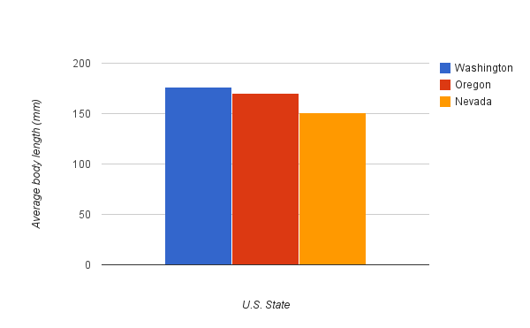
2. For the statistically-inclined, you can have students calculate standard variation using the =stdev() function. Standard deviations are 24.2, 14.2, and 9.8 for WA, OR, and NV, respectively. And if you’re curious, this is a significant relationship. The p-value for the ANOVA run on the subset of 40 pikas from each state is 2.36 x 10-9. For the full data set, the differences were even more dramatic (p=4.75 x 10-18).

***Elevation and Body Size: North Cascades National Park***

1. Does body size change with elevation like it does with latitude? Students address this question in this portion of the exercise.
2. The first goal of this portion of the lesson is for students to problem solve a plan for how they can analyze a new data set. For this reason, this portion of the lesson is very open-ended and allows them to direct their own inquiry-based learning. If you would prefer a more guided lesson for this part of the module, the data set can be divided into elevational bands (e.g. 0-600 m; 601-1000 m; 1001-1700 m) and analyzed using the same protocol described in the State-Based Data section.
3. In the provided data set, there is very little to no trend between body size and elevation. There is a slight increase, but it is not significant. Though there is no major trend in this data, there is a great deal of literature showing that populations of organisms at the top of a mountain are often larger than members of their same species at the bottom of a mountain. But this is highly dependent on the life history of the species. For this kind of selection to occur, populations must be isolated from one another and the differences (selection pressures) in climate on the elevational gradient must be fairly extreme.
4. To begin this part of the lesson, we suggest showing the Pika Body Size and Natural Selection video:

[www.vimeo.com/122472847](http://www.vimeo.com/122472847)

1. Students can approach the question in a few ways. Two potential graphs are shown below. If students choose a bar graph, as in the State-Based data, they would expect larger pikas in the cold environments (at the highest elevations) and smaller pikas in warmer environments (at lower elevations). If students choose an x-y scatter graph, they should expect to find a positive trend in their graph, again with smaller pikas at lower elevations. As you can see in the sample graphs, neither of these predictions hold for this data set.

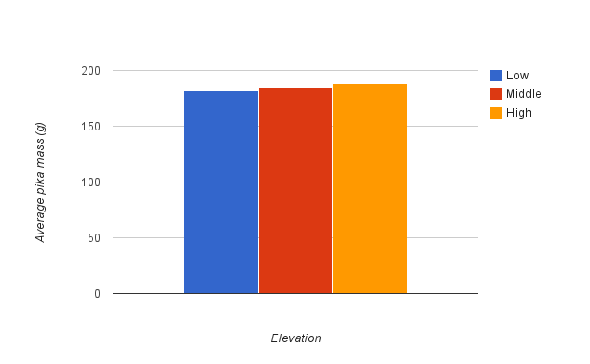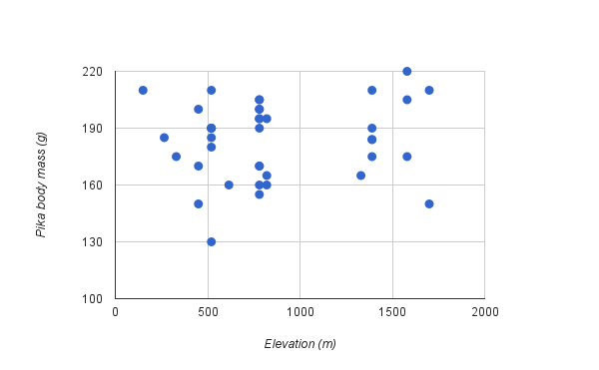

1. Why is this data different from the state-based data (*Question 4*)? We don’t know for sure, but we have a few theories:
   1. Darwin’s requirements: There is certainly variation in the population and there is no reason to believe inheritance patterns are different than in the state-based data set. This leaves us with two options: (1) Perhaps there are enough resources to allow for high survival and low competition; or (2) Maybe the temperature difference isn’t drastic enough along the elevational gradient to lead to unequal survival.
   2. Measurement differences: The state-based data was pika length, while the North Cascades pikas were measured in body mass. Mass certainly should relate to volume and uphold the typical body size and temperature pattern, but mass can also be affected by animals’ nutrition and health.
   3. Study area differences: The state-based study populations are very far apart, making dispersal between sites unlikely (pikas can disperse between 2-10 km). In the North Cascades study, movement between populations is probably more frequent, and this, combined with some of the “Darwin’s requirements” factors listed above (especially high survival), could be leading to more mixing of populations. Also, there are much smaller sample sizes for this data set than for the state-based data. Given the weak trend here, more sampling might lead to a stronger trend.
   4. Other theories: Your students will probably have many more great ideas!
2. *Question 5*: Climate change. If temperatures get warmer, we would expect smaller body sizes to be selected over time. There is a lot of variation in body size, so this does seem like a possibility.