A bar graph is used to display data for which the independent variable (on the x-axis) is in categories. Such data are known as discrete or categorical data. In the example given below, we want to graph the number of carnivore species in four U.S. states. Because U.S. states are categories and can’t be placed on a number line, this is best graphed as a bar graph. In Google Sheets, a graph with categories on the x-axis is called a “column graph” so these instructions will refer to our graph as a column graph from now on.

STEP 1: Organize and Highlight Data

- To easily graph your data in Google Sheets, it is important to organize your data in your spreadsheet. Your categories can either be in columns, like so:

 | Colorado | Kansas | Montana | Virginia
# of Carnivore Species | 23 | 17 | 22 | 13

or in rows, like so:

 | # of Carnivore Species
Colorado | 23
Kansas | 17
Montana | 22
Virginia | 13

In addition to labels for each of your categories, including a label for your dependent variable (in this case, # of Carnivore Species) will make the graphing process easier. For the remainder of this example, we will assume your categories are in columns, to keep things simple.

- Once your data are organized, highlight all data and labels.
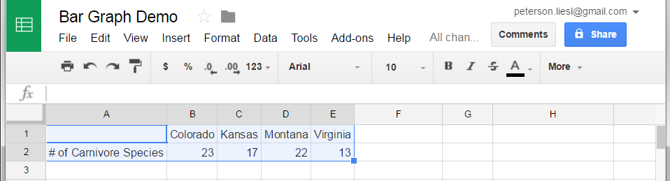

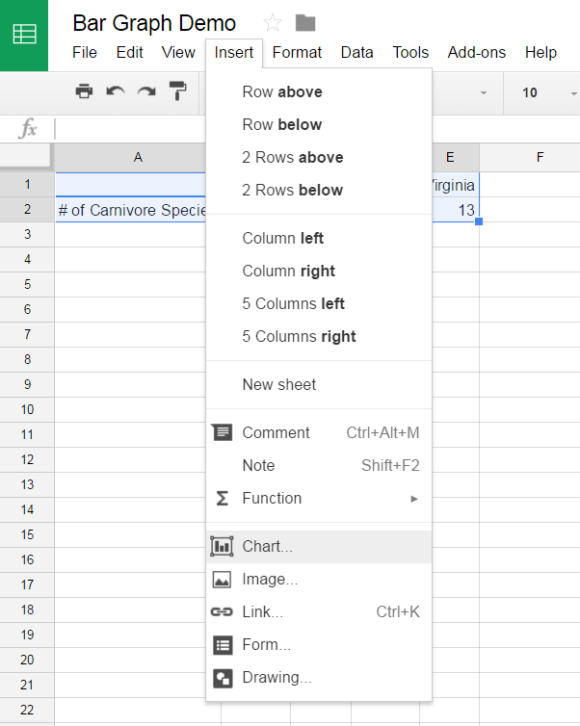
STEP 2: Insert a Graph
- With data and labels highlighted, click “Insert” “Chart”

- With your data organized as above, the graph should already appear as a column chart by default, as pictured below. If a column chart doesn’t appear, click on “Chart types,” scroll down to “Column” and select the first option.
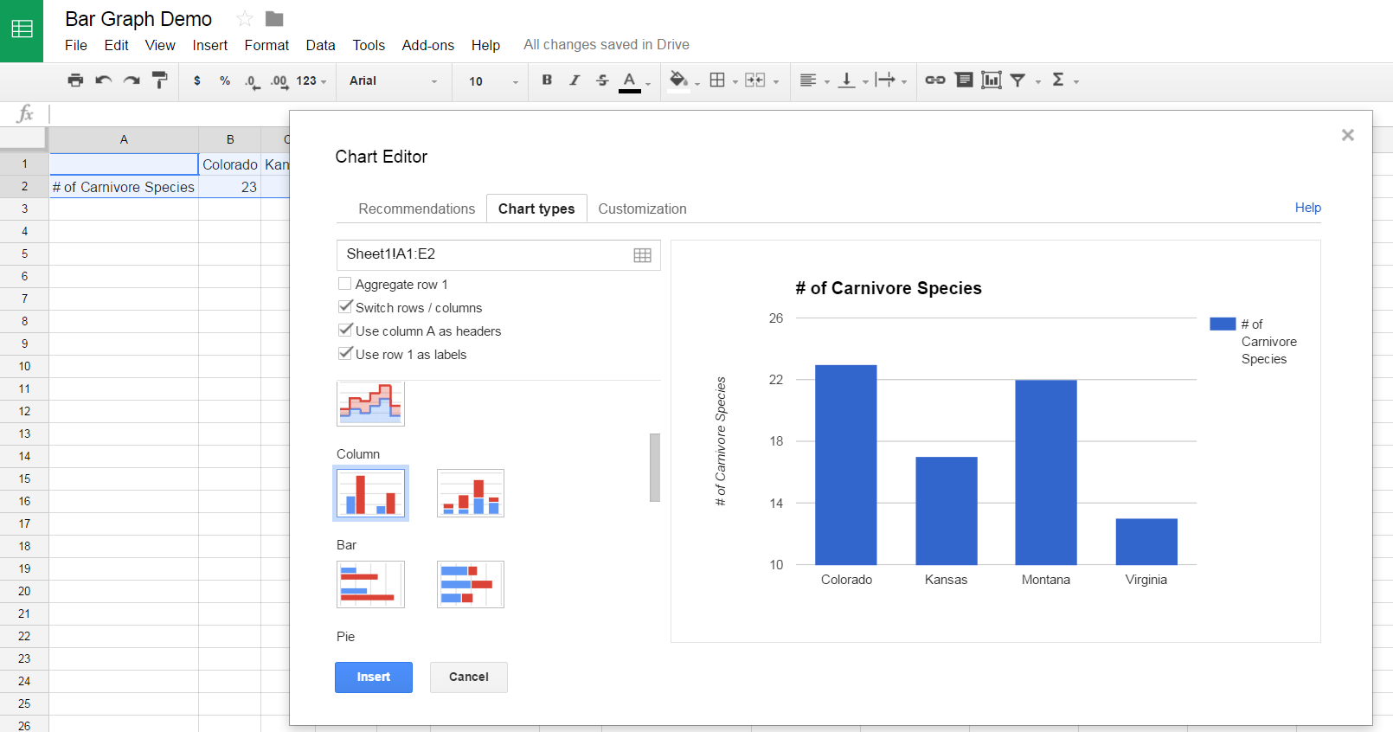

STEP 3: Customize Chart

Clicking “Customization” allows you to customize your chart, including changing or eliminating a title, and changing axes and their labels.

Adding Axis Labels
- While there are some labels on the x-axis, it is important to provide an over-arching label for all your categories. In this case, that label would be “U.S. State.”
- To add this label, scroll down to “Axis” and type your desired title in the box below “Title.”
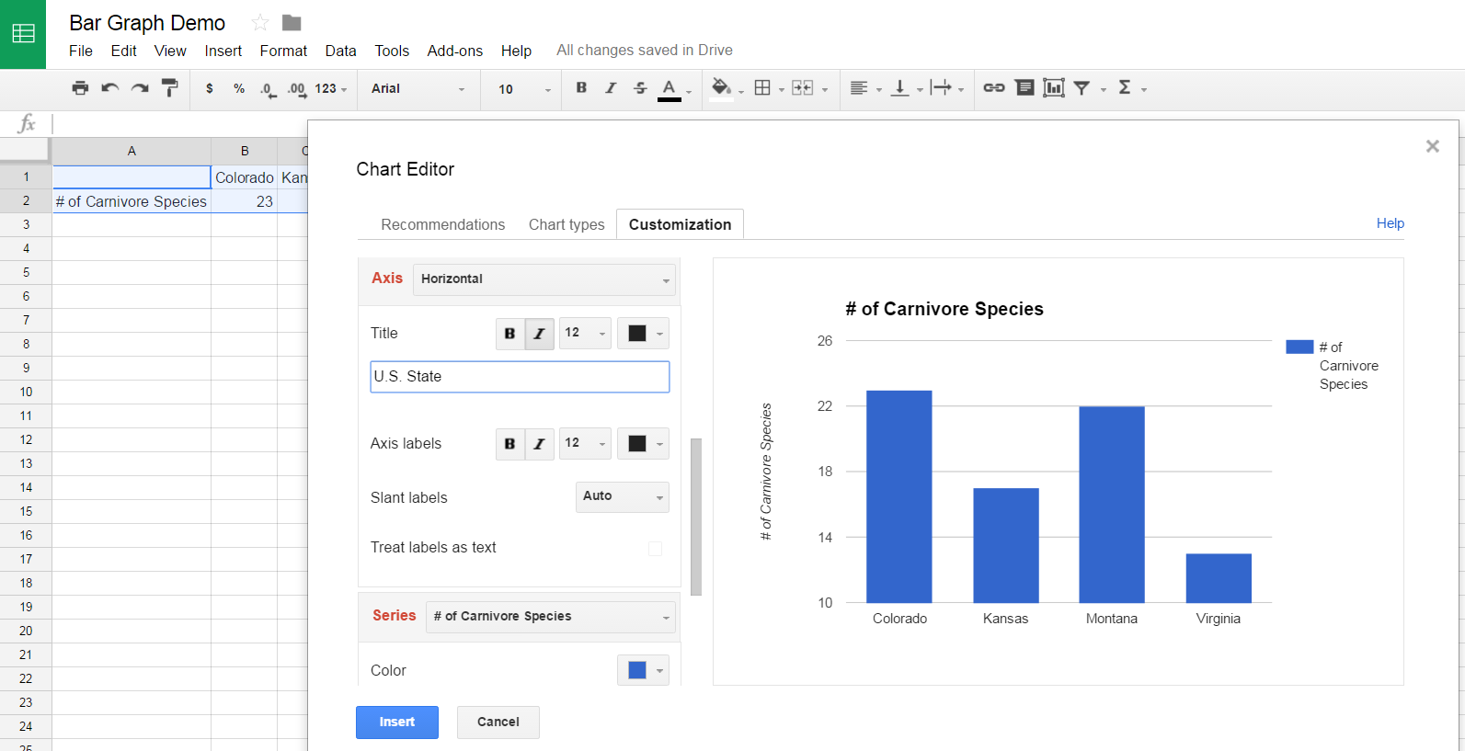

Changing Axis Limits
- A common issue is that the y-axis does not start at 0. To change this, scroll down to “Axis” and change “Horizontal” to “Left Vertical.”
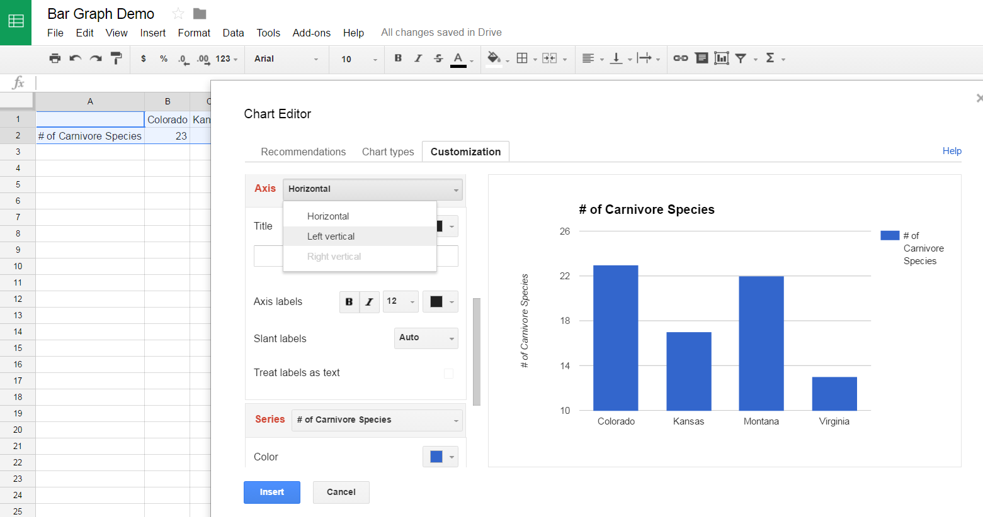

- Then click in the box below “Min” and type “0” as your minimum value.
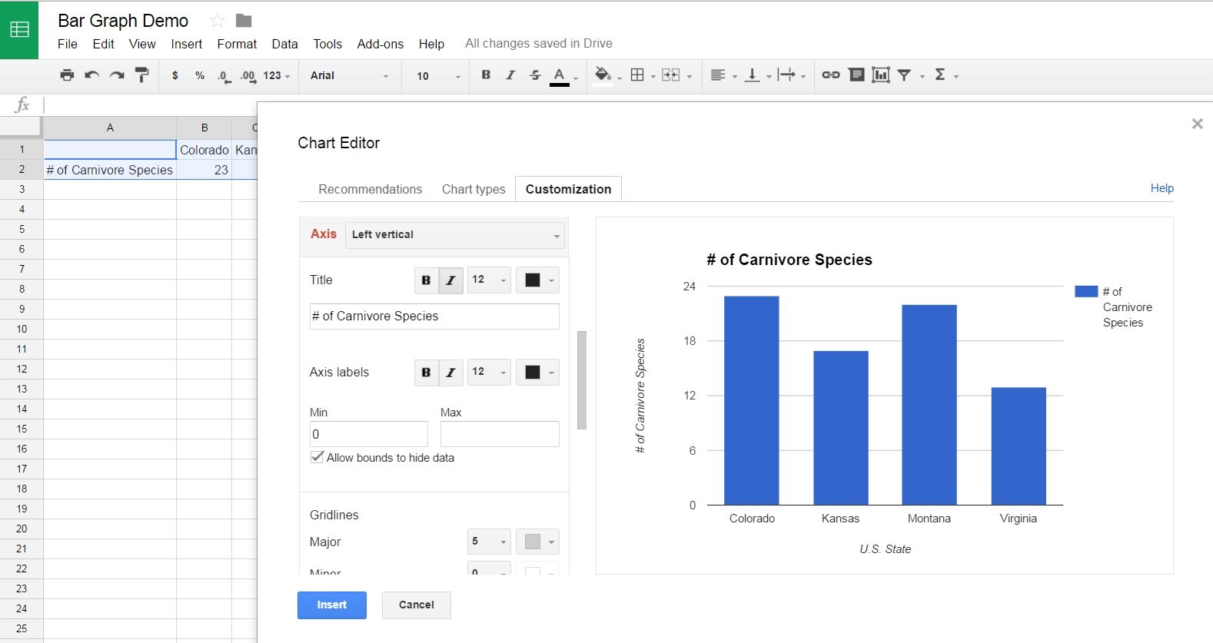

- To complete your chart, click “Insert.”
- If at any point you would like to edit your graph again, you can return to the Customization screen by clicking the small arrow in the top right corner of your chart and selecting “Advanced Edit.”

